- When we need to sign up to a particular application, we must use unique username, for that we used excel sheet and then we have fetched those values but same thing we can do using beanshell.
- Here I don’t have any application which needs unique username to sign up hence I am using another script and will explain how can achieve that.
- In Test Plan level, I have created a variable called as username and passed value for that.
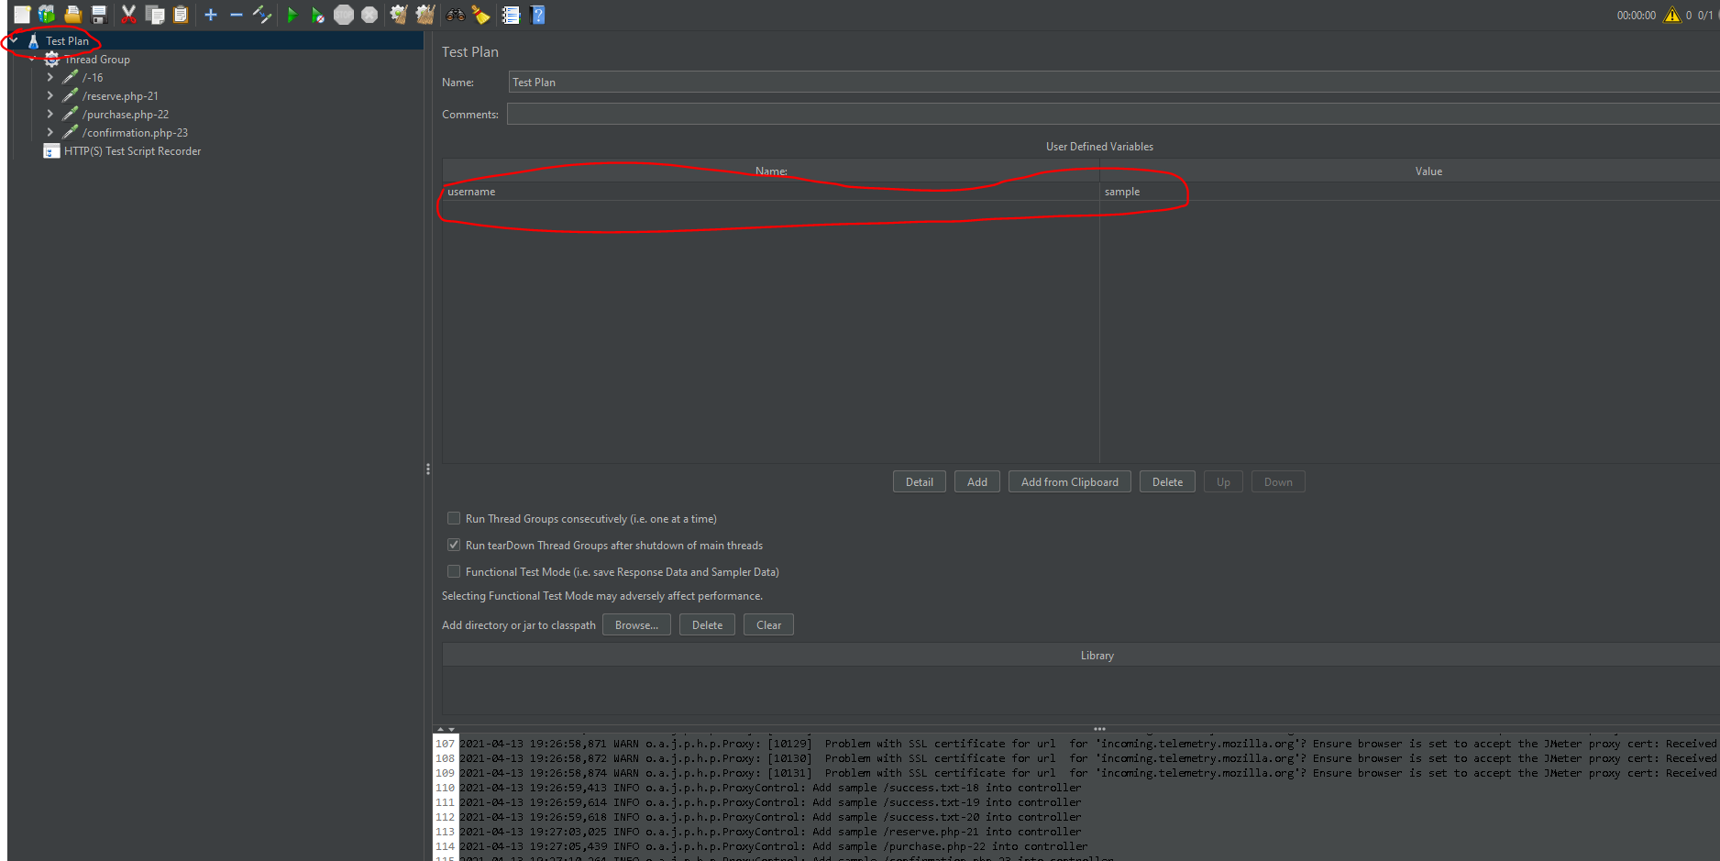
- Now I am using that value from username variable under reverse sampler.
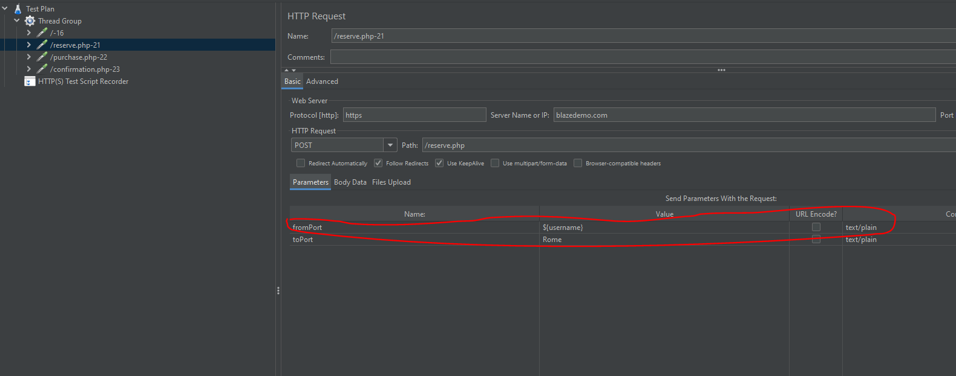
- Now every time the value of the username will come and fall here, but I need different username for every run, if we have 10 threads for that scenario to do that, we need to add bean shell sampler and follow below process.
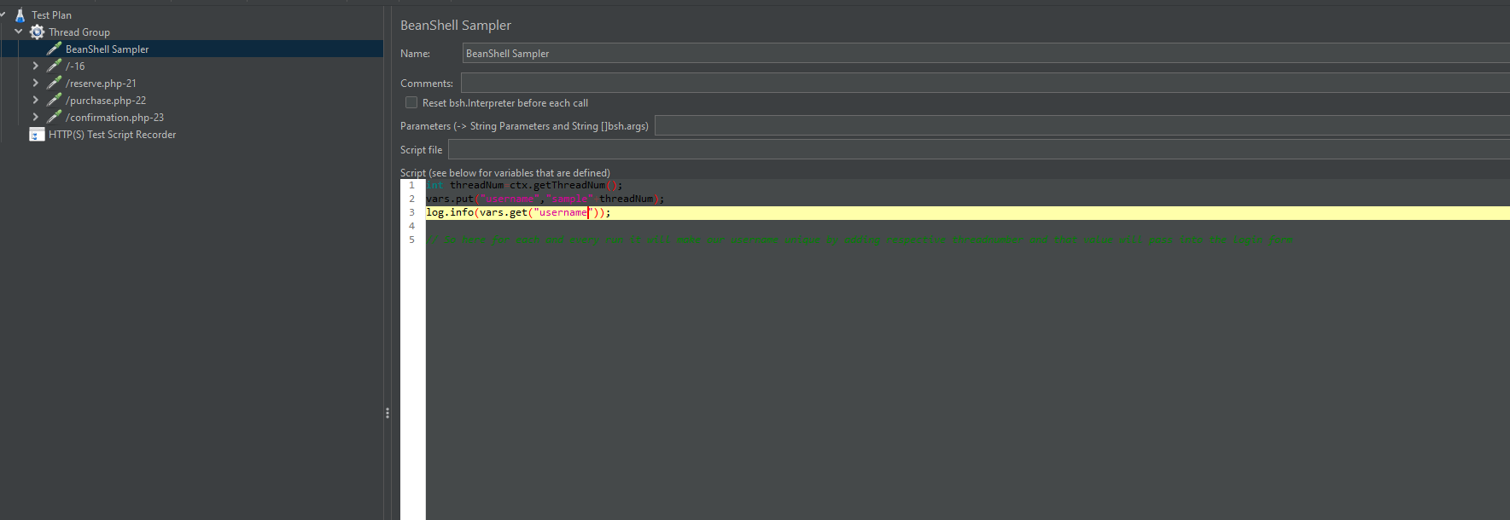
- In Thread Group, I have mentioned Number of threads as 10, so that it will execute 10 times and each time it will add thread number to our sampler.
